Program 1:
Inline.html
<!DOCTYPE html>
<html>
<head>
<title>Inline CSS</title>
</head>
<body>
<h1 style="color: blue; text-align: center;">
ONLINE COLLEGE NOTICE BOARD
</h1>
<p style="color: red;">
Exam starts from March 10.
</p>
</body>
</html>
Op:
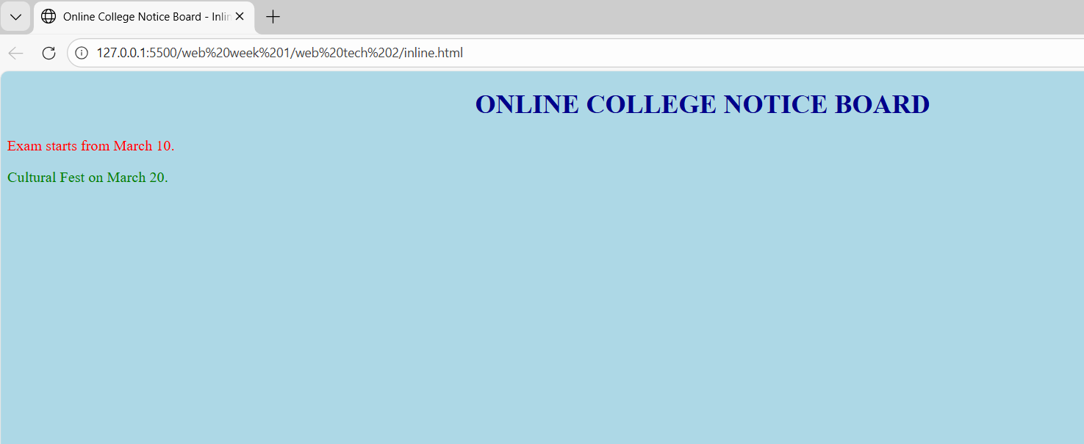
Internal.html:
<!DOCTYPE html>
<html>
<head>
<title>Internal CSS</title>
<style>
body {
background-color: lightyellow;
}
h1 {
color: green;
text-align: center;
}
p {
color: blue;
}
</style>
</head>
<body>
<h1>ONLINE COLLEGE NOTICE BOARD</h1>
<p>Culturals on March 20.</p>
</body>
</html>
Op:
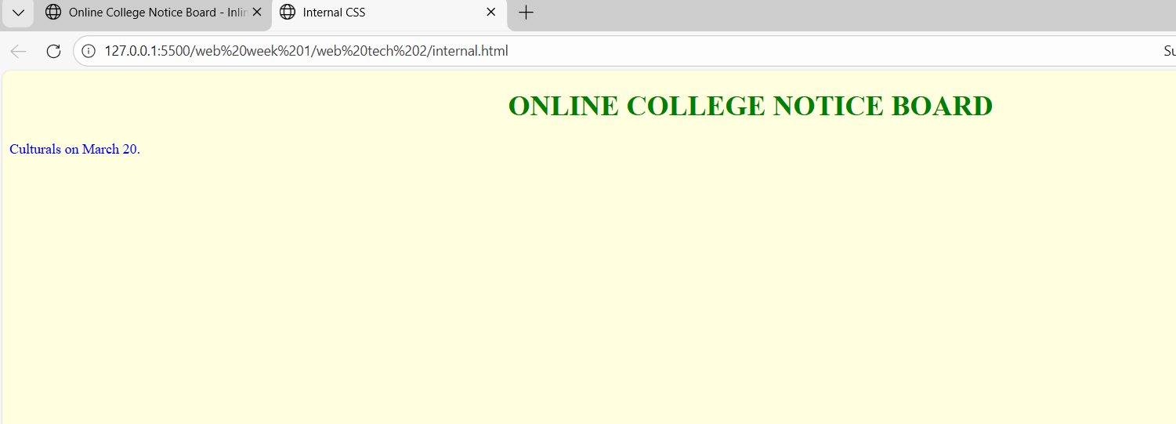
External.html:
<!DOCTYPE html>
<html>
<head>
<title>External CSS</title>
<link rel="stylesheet" href="style.css">
</head>
<body>
<h1>ONLINE COLLEGE NOTICE BOARD</h1>
<p>Sports Day on March 25.</p>
</body>
</html>
Style.css:
body {
background-color: lightblue;
}
h1 {
color: darkred;
text-align: center;
}
p {
color: purple;
}
Op:
